Name: ____________________
Trustworthy 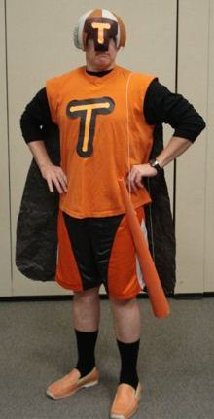 Writing Assignment

Choose AT LEAST 2 questions below to respond using complete sentences. First, save this Word document under you folder on your computer.
- Click “file”
- Click “save as”
- Locate your H: drive with your name on it and select it
- Click “save”.
Now you can start typing but remember to save before you end computer lab. When you finish your assignment, you can delete the questions you didn’t answer and ask the teacher to print. Have fun!
---------------------------------------------------------------------------------------------------------------------
1. Judy begins her blog by having us imagine living in a world where you can’t trust anybody. She shows two examples that illustrate her point. These include crossing the street and ordering food at a café. Write about another example that shows how important trust is in our daily lives.

2. Write about the importance of honesty and trust in making our society work.

3. Describe an important relationship in your life right now. What role does trust play in that relationship? How did you earn each other’s trust?

4. Write about a time when you saw somebody lie. What was the situation and how did it feel to witness it? What did you do? Would you do the same thing again?

5. Write about a time when you were lied to. How did you feel? What did you need from that person to trust him/her again?

6. In the video, one girl talks about “that big talk” you have to have with your parents after you’ve been caught lying and how it’s awkward and scary. Write about a time when you had to have that talk. What was it like? What did your parents say? What parts of what they said did you agree/disagree with? Did that talk change the direction of your relationship with them?

7. Write about the role guilt plays in lying. In the video, one kid says that “after you’ve lied and people find out, you have a guilty feeling you carry around with you.” Do you agree with that? If so, in what way?

8. Write about a time when you told a lie that got out of hand. What happened and how did you undo the damage?

