Name: ____________________
Respect 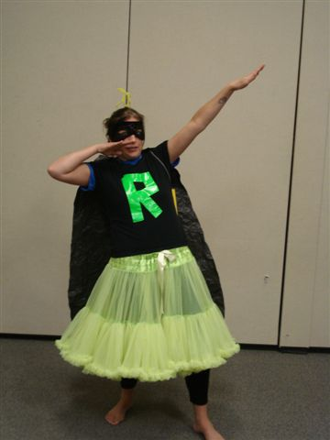 Writing Assignment

Choose AT LEAST 2 questions below to respond using complete sentences. First, save this Word document under you folder on your computer.
- Click “file”
- Click “save as”
- Locate your H: drive with your name on it and select it
- Click “save”.
Now you can start typing but remember to save before you end computer lab. When you finish your assignment, you can delete the questions you didn’t answer and ask the teacher to print. Have fun!
---------------------------------------------------------------------------------------------------------------------
Video Questions (Choose 10 and delete the rest)
1. What are some respectful behaviors?

2. How important is respect in our lives? Why?

3. Do you consider yourself to be a respectful person? Why, or why not? In what ways do you show respect to others?

4. One student in the video said that you don’t have to like someone to respect him/her. Do you agree?
Why, or why not?

5. Describe one person you respect in your life. What does this person do to earn your respect?

6. Does a person have to earn respect, or do all people deserve it?

7. How do you show respect to others? Do you show respect to strangers differently than you do to friends?

8. Does it feel different to be disrespected by a stranger than to be disrespected by a friend? How?
9. What are the benefits of people treating each other with respect?

10. When was the last time you disrespected someone? What was the reason? How did you express this disrespect? What effect did your behavior have?

11. When was the last time someone disrespected you? What do you think was their reason for treating you in that way?

12. What are some reasons people show disrespect for others?

13. How do you feel when someone judges you without knowing you or giving you a chance?

14. How do you feel when someone you disagree with calls you a name?

15. In the video several students talked about the role that “differences” play in how people respect or disrespect others. What role do you think differences play in our positive or negative attitudes to other people?

16. Does respect play a role in harmonious race relations? Explain.

17. In the video some students talked about the idea that, “It’s one thing to respect a person, but another to respect that person’s beliefs.” What did she mean? Can you think of someone you know who has a different set of beliefs than you? How do you respond to different beliefs?

18. In the group discussion, Vanessa and Aidan talked about the incident with the water bottle in which Aidan cut Vanessa and didn’t give her a real apology right away. Have you ever experienced something similar? What happened?

19. How do you feel when someone bumps into you in the hall and doesn't apologize? What does saying “I’m sorry” have to do with respect?

20. Agree or disagree: Courtesy and politeness are only for adults. Explain your answer.
21. One of the kids in the video said that if someone treats you with disrespect, you don’t have to treat that person with respect. Do you agree? How should you respond to someone who is disrespectful of you?

22. How do you think respect affects your community, the world?

23. Does everyone deserve respect? Why? Or why not?

24. Think of the students from Georgia and their stream clean up. Have you or your friends done something to help take care of our environment? What did you do? How did it make you feel?

25. What is the difference between respecting a person and respecting our planet?

Writing Assignment (Choose 2 and delete the rest)
1. Write down the name of someone in your life right now whom you respect very much. Name two things that person does that cause you to respect him/her. Do you share either of those traits with that person?

2. Write about a time recently when you felt you didn’t treat someone with respect. Describe the situation. Why did it happen? Was it the right thing to do? What were the consequences? How did it make the other person feel? Would you behave differently if you were given another chance? How, and why or why not? What did you learn from the experience?

3. Write about a time when you felt you were treated disrespectfully. What suggestions would you have for the other person to treat you better?

4. Write about something you see in your school, your neighborhood, or the world that shows a lack of respect. What would you do to change it?

5. Write a letter to someone in your life whom you respect. Tell why and how you respect him/her. Send the letter to that person.

6. One student in Benjy’s blog talks about how people make assumptions that aren’t necessarily true about other people. Write about a time when someone made an assumption about you, or you made an assumption about someone else. What does this situation have to do with respect?

7. Make a list of ways in which people show disrespect for Mother Earth. Now make another list of things we can do to show her our respect.

8. Describe three things you could do to be a more respectful person. How would that affect your relationships with others? How does it benefit you to be a respectful person?

